CURRICULUM VITAE

PERSONAL DETAILS:

- Name: Saeed A.Jabbar Al-Sharqi
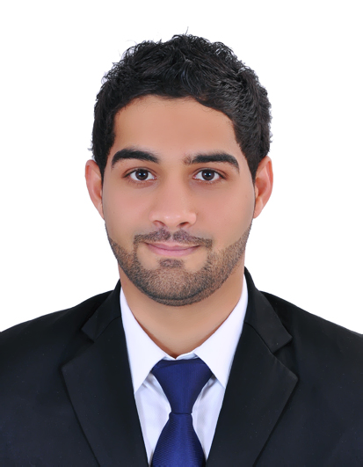
- Date Of Birth: 25 April 1990
- Nationality: Bahraini
- Martial Status: Single
- CPR Number : 900411457
- Address: Villa: 2578Road:1644
Hamad Town1216, Bahrain
- Contact: (+973)36186896
(+973) 33890376
- E-mail: saeedsharqi@gmail.com
- License: Available

QUALIFICATIONS:
Qualification Received Institute / School From To
- Secondary School Certificate Sheik Isa Bin Ali Secondary School 2005 2008
EXPERIENCE:
Position Held Place From To
- Cement Weight Bridge 2015 2019
- Courses:
- 1st Oct 2018 to Date : Involved In Elderly Sitter Program Sponsored By Bahrain Women Association:
- 1st oct - 15 Nov 2018 : college of health & science.
- 15 Nov - 13 Dec 2018 : Muharraq Maternity & Geriatric Hospital.
- 18 Dec 2018 - 16 Jan 2019 : National Bank Of Bahrain Elderly Home.
- 20 Jan 2019 - 5 April 2019 : Ahmed Ali Kanoo Health Centre.
- 24 Mar - 25 Mar 2019 : American Heart Association.
SKILLS:
- Ability To Work Alone Or Within A Group.
- Hard Worker.
- Problem Solving.
- Accepting Challenge.
- Leadership Skill.
- Good Command Over MS Office (Word , Excel , Power Point ).
- Good Communication Skills.
INTERESTS:
- Playing Foot Ball & All Sports
- Surfing The Internet
REFERENCE
- Available Upon Request.

